Introduction to Algorithms

What is an Algorithm ?

Algorithm refers to a set of rules/instructions that step-by-step define how a work is to be executed upon in order to get the expected results.

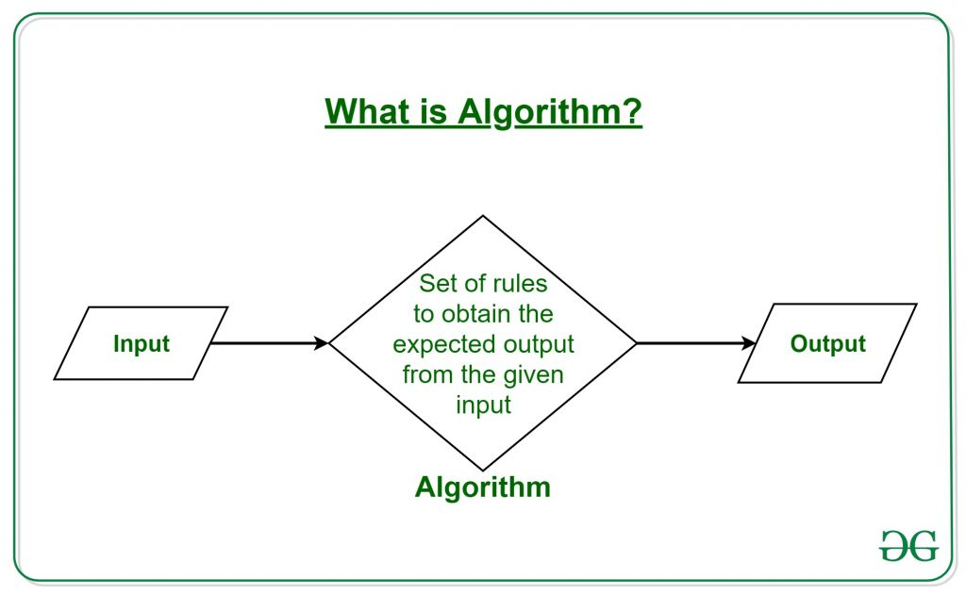
It can be understood by taking an example of cooking a new recipe. To cook a new recipe, one reads the instructions and steps and execute them one by one, in the given sequence. The result thus obtained is the new dish cooked perfectly.
Similarly, algorithms help to do a task in programming to get the expected output.

What are the Characteristics of an Algorithm ?
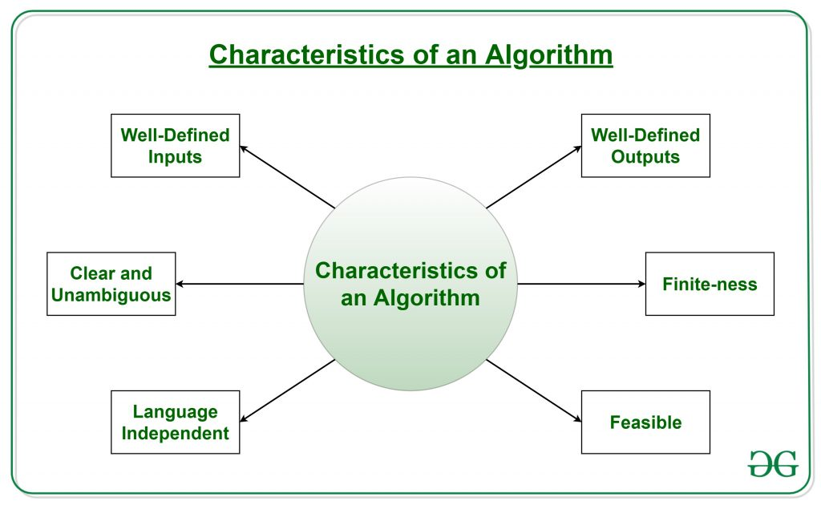
Not all written instructions for programming is an algorithm. In order for some instructions to be an algorithm, it must have the following characteristics:
- Clear and Unambiguous: Algorithm should be clear and unambiguous. Each of its steps should be clear in all aspects and must lead to only one meaning.
- Well-Defined Inputs: If an algorithm says to take inputs, it should be well-defined inputs.
- Well-Defined Outputs: The algorithm must clearly define what output will be yielded and it should be well-defined as well.
- Finite-ness: The algorithm must be finite, i.e. it should not end up in an infinite loops or similar.
- Feasible: The algorithm must be simple, generic and practical, such that it can be executed upon with the available resources. It must not contain some future technology, or anything.
- Language Independent: The Algorithm designed must be language-independent, i.e. it must be just plain instructions that can be implemented in any language, and yet the output will be same, as expected.

Advantages of Algorithms:
- It is easy to understand.
- Algorithm is a step-wise representation of a solution to a given problem.
- In Algorithm the problem is broken down into smaller pieces or steps hence, it is easier for the programmer to convert it into an actual program.

Disadvantages of Algorithms:
- Writing an algorithm takes a long time so it is time-consuming.
- Multiple Branching and Looping statements are difficult to show in Algorithms.

How to Design an Algorithm ?
In order to write an algorithm, following things are needed as a pre-requisite:
- The problem that is to be solved by this algorithm.
- The constraints of the problem that must be considered while solving the problem.
- The input to be taken to solve the problem.
- The output to be expected when the problem the is solved.
- The solution to this problem, in the given constraints.

Example: Consider the example to add three numbers and print the sum.
Step 1: Fulfilling the pre-requisites
As discussed above, in order to write an algorithm, its pre-requisites must be fulfilled.
  - The problem that is to be solved by this algorithm: Add 3 numbers and print their sum.
  - The constraints of the problem that must be considered while solving the problem: The numbers must contain only digits and no other characters.
  - The input to be taken to solve the problem: The three numbers to be added.
  - The output to be expected when the problem the is solved: The sum of the three numbers taken as the input.
  - The solution to this problem, in the given constraints: The solution consists of adding the 3 numbers. It can be done with the help of ‘+’ operator

Step 2: Designing the algorithm
Now let’s design the algorithm with the help of above pre-requisites:
Algorithm to add 3 numbers and print their sum:
  - START
  - Declare 3 integer variables num1, num2 and num3.
  - Take the three numbers, to be added, as inputs in variables num1, num2, and num3 respectively.
  - Make sure the input is only number.
  - Declare an integer variable sum to store the resultant sum of the 3 numbers.
  - Add the 3 numbers and store the result in the variable sum.
  - Print the value of variable sum
  - END

Step 3: Testing the algorithm by implementing it.
In order to test the algorithm, let’s implement it in Python language.

Show code → algorithm_example.py

Algorithm representation
There are a number of different ways an algorithm can be represented:
1) Use a verbal description → Example is the cooking recipe
2) Code → Example is the code we saw before
3) Pseudo code
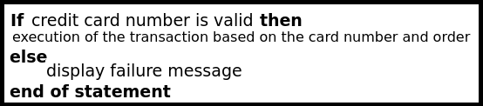
Pseudo code is a middle ground solution. It can be written as a story, but you should remember about keywords (if - if, else - otherwise, as long as - while, etc.)

4) Block Diagram
It is used by business analysts to show how the code should behave to the programmers.
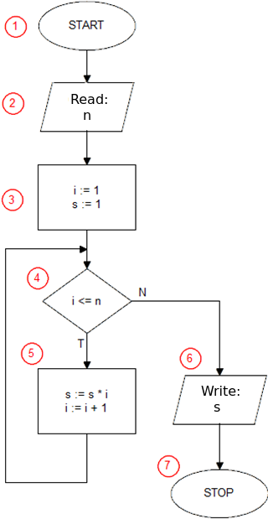
A block diagram is a graphical representation of an algorithm for the purpose of solving a specific task. On such a basis, we set/read the sequence of executed instructions and the flow of the algorithm.
Example:
Factorial Diagram

Block diagram
The features of block diagrams:
- it is easy to use - they represent the steps in the algorithm,
- it has a simple structure - a small number of elements (blocks),
- they can be created with the use of syntax notation of any selected language (various operators, e.g. =vs=),
- it is useful for creating advanced algorithms,
- it is much easier to write the code of a given algorithm on their basis.

Types of block diagrams
There are four types of diagrams:
1) Simple (sequential),
Conditional blocks are not used in such situations. The sequence of execution of individual operations is strictly defined and none of them can be omitted or repeated.
Examples:
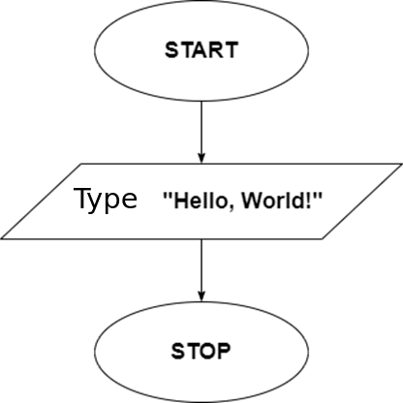
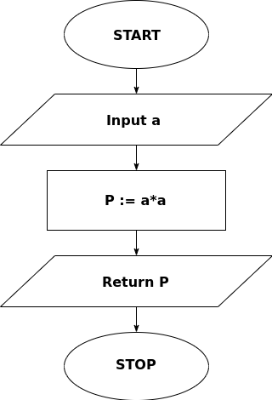
2) Separation
It gives the choice to accomplish a given task using various methods. It has to use at least one conditional block.
3) Loop
Often, during the implementation of a given task, it is necessary to repeat some operations that differ only in their data set. The loop covers that part which is to be repeated.
4) Complex
It is a combination of the above solutions. The diagram for the factorial shows the compound family. Below you can see an example (each block marked with a number will be described later in the material):
Symbols
BORDER BLOCKS
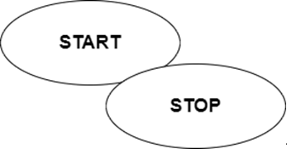

These are oval-shaped blocks that begin and end with the block representation of the algorithm. Only one down arrow comes out of the START block, none come into the block. One arrow enters the STOP block (END, etc.), but no arrow comes out - when the algorithm reaches this block, the execution ends.

ARROW/CONNECTOR

The arrow (connector) clearly indicates the direction of the instruction flow - it should never be divided, the algorithm should clearly move from one block to another. However, it is possible to return using the arrow from the block below to the block above (in such a case it's a loop of the instruction).
OPERATION BOX
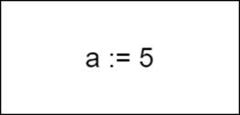
The operation box is represented by a rectangle. Its interior contains all operations / instructions performed during the algorithm's operation (except for the conditional instruction). In this block you can define a variable, change its value, write some simple command in words (eg "add a letter to the end of the current string").

INPUT/OUTPUT BOX
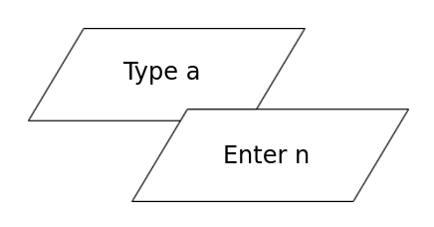
Represented in the diagram by a parallelogram. Input / output boxes are used to contact the user through commands that print values (e.g. print) or ask the user to enter one (e.g. input).

CONDITION BOX
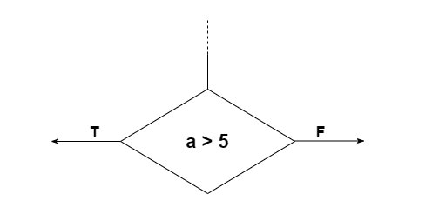
The conditional box stores selection statements (in a diamond diagram). One arrow enters, while two come out: for the value YES (when the condition written in the diamond is true) and for the value NO (when it is not).
WHILE LOOP
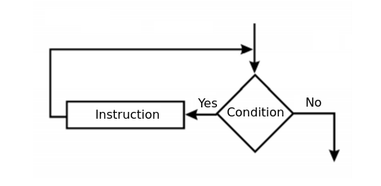
Representation of the while loop: first check the condition, then execute the statement, finally return to the point of checking the condition (starting the next iteration in the loop).

DO WHILE (UNTIL) LOOP
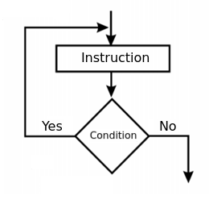
Loop representation until (do while): statement first, then test the condition (plus any potential repeat executions of the statement).

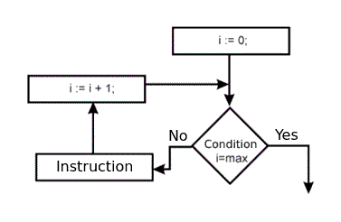
FOR LOOP
Simulation of the for loop: loop the execution of the statement the number of times specified in the diagram; and increase until the value is equal to the max.

Example:

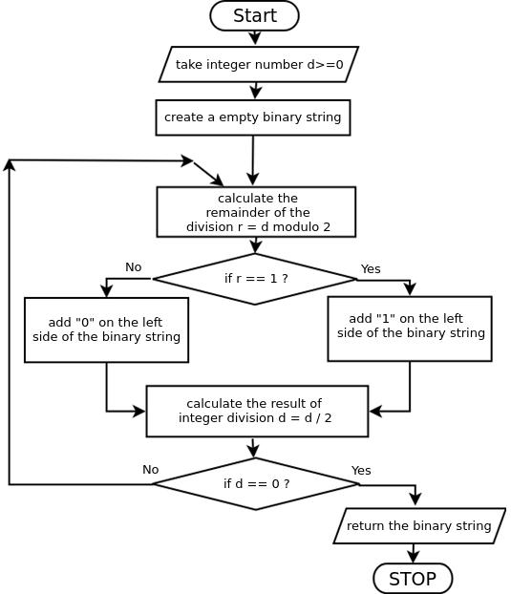
Algorithm for converting a decimal number to a binary number

Exercise 1
Write the code based on the flowchart below.
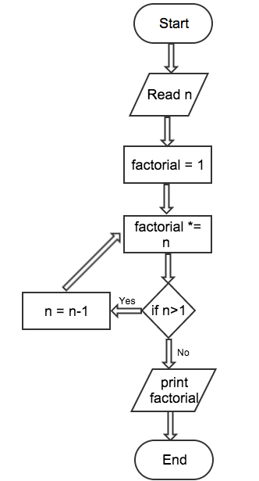

Exercise 2 Answer
Live Coding with Students

Exercise 2
You are given hundred numbers divided in ten sets in the following order.
Set 1: 1-10, Set 2: 11-20, Set 3: 21-30, ….. , Set 10: 91-100
- You have to draw a flowchart based on the algorithm below that will print the sum of each set.
  - Initialize count = 1 and i = 1 (PROCESS)
  - Check if i is less than or equal to 10 (DECISION)
if YES then perform step 3
else STOP
  - Set sum = 0 and j = 1 (PROCESS)
  - Check if j is less than or equal to 10 (DECISION)
if YES then perform step 5
else perform step 9
  - Add count to sum
sum = sum + count (PROCESS)
  - Increment count by 1
count = count + 1 (PROCESS)
  - Increment j by 1
j = j + 1 (PROCESS)
  - Go to Step 4
  - Print sum (I/O)
  - Increment i by 1
i = i + 1 (PROCESS)
  - Go to Step 2
- You have to code the program based on the flow chart.
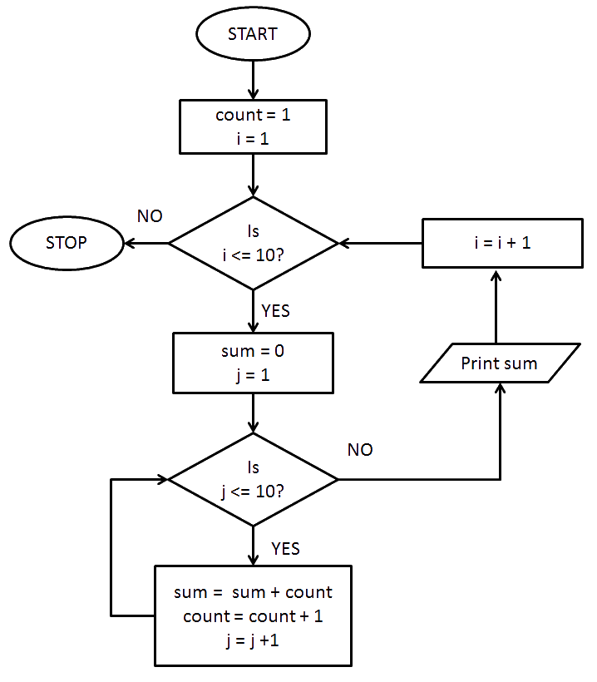
Exercise 2 Answers

Program Code in → sum_of_sets.py

For more Excercises check the Exercises in https://python.en.sdacademy.pro/exercises/algorithms_and_data_structures/algorithms/.

